**HEALTH SERVICES**

**END TERM REPORT**

***BY***

**NAME OF CANDIDATES**

**(Section: K19LC)**

**(Roll Numbers:16,23,35)**

[](https://www.bing.com/images/search?q=lpu+logo&id=5B976D6C6DA3664BD31347D5BB8F0EEA986D9D83&FORM=IQFRBA)

**Department of Intelligent Systems**

**School of Computer Science Engineering**

**Lovely Professional University, Jalandhar**

**APRIL-2020**

**Student Declaration**

This is to declare that this report has been written by us. No part of the report is copied other sources. All information included from other sources have been duly acknowledged. We aver that if any part of the report is found to be copied. We shall take full responsibility for it.

Signature of student

Name: Munmun Sharma

Roll No: 35

Signature of student

Name: Anmol Ahuja

Roll No: 23

Signature of student

Name: Parmeet Kaur

Roll No: 16

**Lovely Professional university**

**10/4/2020**

**TABLE OF CONTENTS**

**TITLE PAGE NO.**

1. **Background and objectives of project assigned**

Our project is based on health services to make a step towards helping people in this particular field (health and services).

Since there is a saying “***health is wealth”*** here our main aim is to provide the facility to people to feel comfortable about their own health related problems.

We are in 21st century where we are more dependent on technologies because of our convenience and our comfortable behaviour with developing technologies. So here we are presenting a new option for us, for people so that they can take their health-related problems in their hands.

Our main purpose to make this project is to make every thing in the pockets of the user (people). Providing them with online consultancy to online appointment with the best specialists of that particular health department.

For convenience,

Every single detail has been depicted in simple pattern so that people will not be dissatisfied with our attempts towards their health.

**DESCRIPTION OF PROJECT:**

In order to make a website based on health-related services

We have focused on the way that it should be simple so that an illiterate person can also handle with less efforts.

Since it is basically related to the health services and it is the thing which should be provided to every person in every possible way our designing is way simple aiming to cover each health department.

All possible important links have been provided on the webpage itself. Patients no longer need to wait in long queues.

Less wastage of stationary products due to less paper work. Earlier everything was done manually which was highly time consuming an expensive but this website has made it easier .This website is designed in interactive manner and is able to give users the knowledge of expertise ,experience and hospitality of HEALTH-O-CARE. Through this website patients not only get the information about expertise field but also eminence of the hospital.

The website consist of webpages giving information bout appointments availability , latest updates and news of the health care center.

**Description of Work Division in terms of Roles among students :**

Since this was the group project assigned to us as the mid-term project (of three students) so we have made our full efforts in making this “HEALTHO-CARE” website.

Data collection, coding, designing of webpages, documentation was properly distributed among us.

**Implementation of scheduled work of project:**

1. **Some designs of our webpages**

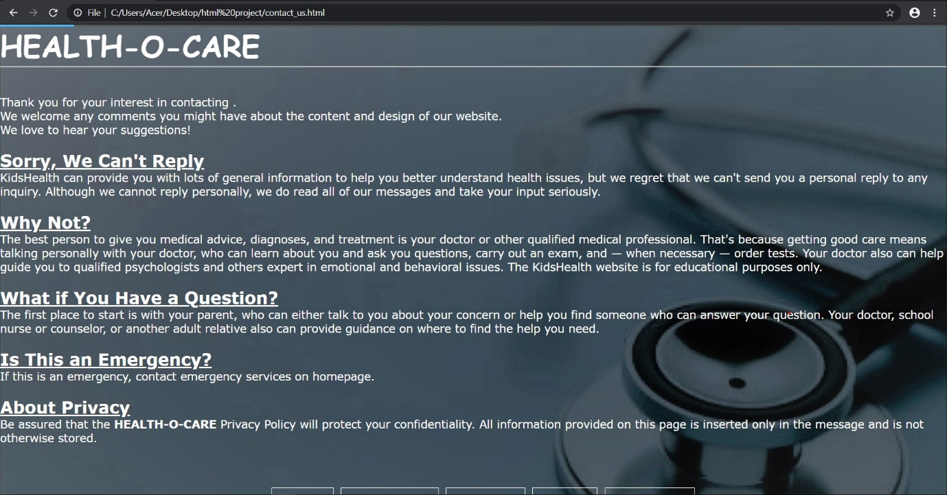

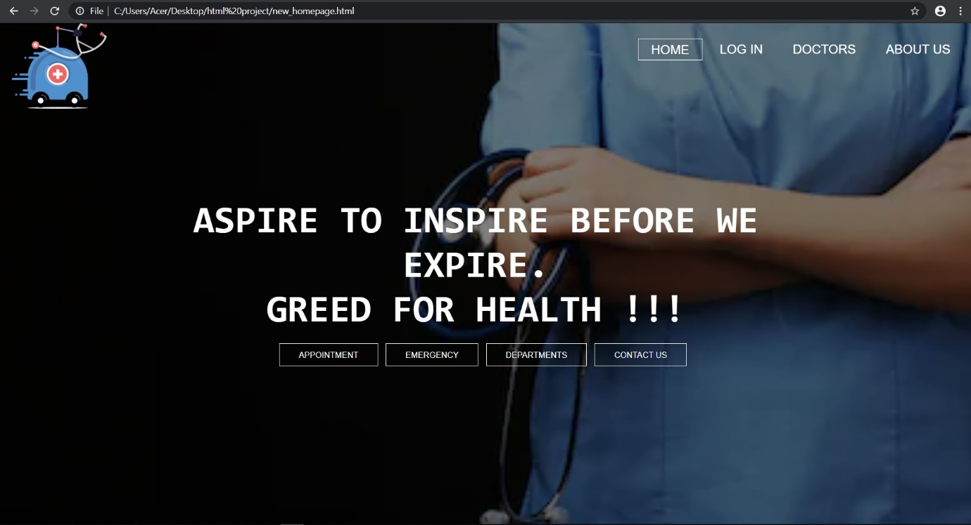

1. **Html part**

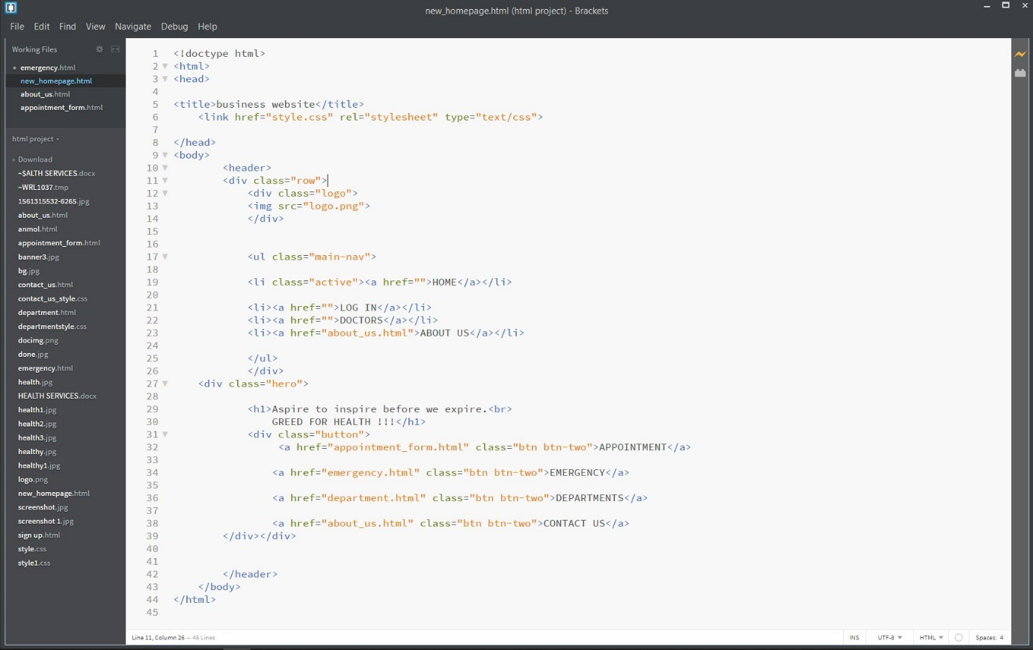

1. **CSS Part**

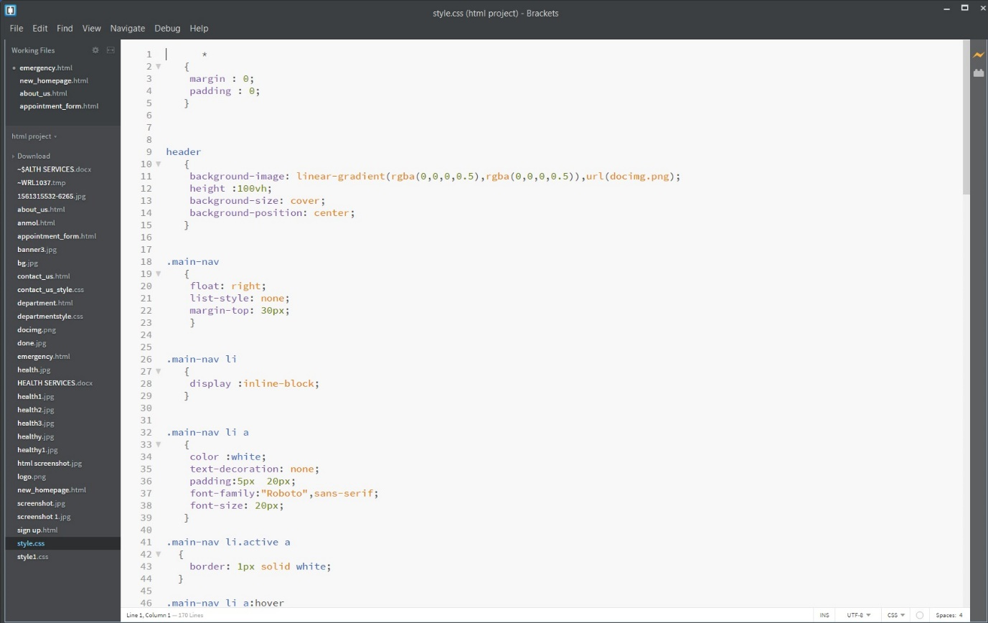

**Technologies and framework used**

We have used BRACKETS for coding: including CSS and JavaScript.

**SWOT analysis involved in project**

Since our project is based on health services, it should be simple enough to be easily handled by the user, this thing we have kept in mind.

We can work more in this field I guess if necessary to meet the needs of patients.

**BONAFIDE CERTIFICATE**

Certified that this project report “HALTH-O-CARE” is the bonafide work of “MUNMUN, ANMOL AHUJA , PARMEET KAUR” who carried out the project work under my supervision

Dr. Dhanpratap Singh

25706

School of Computer Science and Engineering